**Table of Contents**

**A. National TB Program**

**B. Status indicators**

**C. Rapports qualite de soins**

**D. HeathQual Indicators**

**E. Statistiques de services**

**Key**

Indicators are referred to by section letter (A – E) and #

## 

# A. National TB Program

1. Pourcentage de symptomatiques respiratoires examinés parmi les SR identifiés

Percent of patients with respiratory symptoms who had a sputum (TPM) ordered.

|  |  |
| --- | --- |
| Numérateur: nombre de symptomatiques respiratoire examines  Dénominateur: nombre de symptomatiques respiratoires identifies. | **Numerator:** Cough > 2 weeks OR dyspnea AND sputum ordered (TPM)  **Denominator:** Cough > 2 weeks OR dyspnea |

**Numerator**: Respiratory symptoms and sputum ordered

1. Respiratory symptoms. Either of the following:
   1. Cough > 2 weeks | touxGreat2 = 1
   2. Dyspnea | dyspnea = 1
   3. 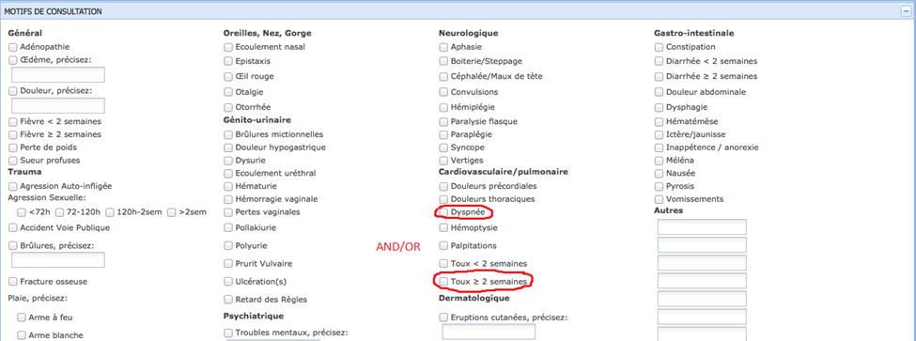
2. Sputum ordered. Any of the following:
   1. TPM + resulted | crachat = 1
   2. TPM - resulted| crachat = 2
   3. TPM on TB forms
      1. TPM +
         1. marked“crachat” | tbDxCrachat = 1
         2. “Pos Bacilloscopie” on Mois 0 | tbEvalresult0 = 1
      2. TPM –
         1. “Neg Bacilloscopie” on Mois 0 | tbEvalresult0 = 2
      3. 

**Denominator**: Respiratory symptoms

1. Respiratory symptoms. Either of the following:
   1. Cough > 2 weeks | touxGreat2 = 1
   2. Dyspnea | dyspnea = 1



1. Pourcentage de symptomatiques respiratoires positifs par rapport aux symptomatiques respiratoires examinés

Percent with respiratory symptoms who have a positive sputum (TPM +)

|  |  |
| --- | --- |
| Numérateur: nombre de symptomatiques respiratoire positifs  Dénominateur: nombre de symptomatiques respiratoires identifies. | **Numerator:** Cough > 2 weeks OR dyspnea AND positive sputum (TPM+) **Denominator:** Cough > 2 weeks OR dyspnea AND a sputum resulted (TPM positive or negative). |

**Numerator**: Respiratory symptoms and TPM +

1. Respiratory symptoms. Any of the following:
   1. Cough > 2 weeks | touxGreat2 = 1
   2. Dyspnea | dyspnea = 1
   3. 
2. Sputum positive. Any of the following:
   1. TPM + resulted | crachat = 1
   2. TPM + on TB forms
      * 1. marked“crachat” | tbDxCrachat = 1
        2. “Pos Bacilloscopie” on Mois 0 | tbEvalresult0 = 1
        3. 

WARNING: The patient with respiratory problems can be identified in one visit and have positive sputum in the next visit. Therefore, therefore the sputum result should not be linked with the same encounter but rather the encounter to follow.

**Denominator**: patients with respiratory problems who had a sputum resulted.

1. Respiratory symptoms. Either of the following:
   1. Cough > 2 weeks | touxGreat2 = 1
   2. Dyspnea | dyspnea = 1
   3. 
2. Sputum resulted. Any of the following:
   1. TPM + resulted | crachat = 1
   2. TPM - resulted| crachat = 2
   3. TPM on TB forms
      1. TPM +
         1. marked“crachat” | tbDxCrachat = 1
         2. “Pos Bacilloscopie” on Mois 0 | tbEvalresult0 = 1
      2. TPM –
         1. “Neg Bacilloscopie” on Mois 0 | tbEvalresult0 = 2
      3. 
3. Adult (>+ 15) pourcentage de nouveaux cas TPM+ par rapport au nombre total de cas (based on radiography) de TB pulmonaire

Percent of new adult pulmonary TB patients with positive sputum (TPM+)

|  |  |
| --- | --- |
| **Numérateur**: nombre de TPM+ diagnostiques chez les plus de 15ans  **Dénominateur :** nombre total de TB pulmonaire chez les plus de 15ans | **Numerator:** New adult pulmonary TB patients with positive sputum (TPM+)  **Denominator:** New adult pulmonary TB patients |

**Numerator**: New adult cases of TPM+

1. Age >=15
2. marked “Nouveau diagnostic” | tbDxNew = 1
3. TPM+
   1. One of the following:
      1. marked“crachat” | tbDxCrachat = 1
      2. “Pos Bacilloscopie” on Mois 0 | tbEvalresult0 = 1

**Denominator**: New adult pulmonary TB patients cases (TPM + or -)

1. Age >=15
2. New TB:
   1. New: “Nouveau diagnostic” | tbDxNew = 1
3. Pulmonary TB:
   1. Any of the following:
      1. “Diagnostic Bas sur X-Ray” | tbDxXray = 1
      2. “Diagnostic Bas sur crachet” is marked | tbDxCrachat = 1
      3. Classification de maladie Pulmonaire” | tbClassPulmonaire = 1
      4. “Pos Bacilloscopie” on Mois 0 | tbEvalresult0 = 1
      5. 
   2. None of the following:
      1. “Classification de maladie Extra-Pulmonaire” is not marked | tbClassExtra ≠ 1
      2. Meningite, pleural, miliare, ganglionnaire, intestinale, or “other” are not marked | tbMeningite, tbPleurale, tbMiliaire, tbGanglionnaire, tbIntestinale, or tbClassOther ≠ 1
      3. 
4. Enfants (< 15) pourcentage de nouveaux cas TPM+ par rapport au nombre total de cas (based on radiography) de TB pulmonaire

% of new child pulmonary TB patients with positive sputum (TPM+)

|  |  |
| --- | --- |
| **Numérateur**: nombre de TPM+ diagnostiques chez les moins de 15ans  **Dénominateur :** nombre total de TB pulmonaire chez les moins de 15ans | **Numerator:** New child pulmonary TB patients with positive sputum (TPM+)  **Denominator:** New child pulmonary TB patients |

Same specifications as A3 except age < 15.

1. Adult (>= 15) pourcentage de nouveaux cas TPM- par rapport au nombre total de nouveaux cas de TB pulmonaire

Percentage of new adult pulmonary TB patients with negative sputum (TPM -)

|  |  |
| --- | --- |
| **Numérateur**: nombre de TPM- chez les plus de 15ans  **Dénominateur**: nombre total de TB pulmonaire chez les plus de 15ans. | **Numerator:** New adult pulmonary TB patients with negative sputum (TPM -)  **Denominator:** New adult pulmonary tb cases. |

**Numerator**: Total (new) pulmonary TB with TPM -

1. Age >=15
2. New TB:
   1. New: “Nouveau diagnostic” | tbDxNew = 1
   2. 
3. Pulmonary TB (not including TPM +):
   1. Any of the following:
      1. “Diagnostic Bas sur X-Ray” | tbDxXray = 1
      2. Classification de maladie Pulmonaire” | tbClassPulmonaire = 1
      3. 
   2. None of the following:
      1. “Classification de maladie Extra-Pulmonaire” is not marked | tbClassExtra ≠ 1
      2. Meningite, pleural, miliare, ganglionnaire, intestinale, or “other” are not marked | tbMeningite, tbPleurale, tbMiliaire, tbGanglionnaire, tbIntestinale, or tbClassOther ≠ 1
      3. 
4. TPM –
   1. Any of the following
      1. “Neg Bacilloscopie” on Mois 0 | tbEvalresult0 = 2

**Denominator**: Total (new) pulmonary TB patients (TPM + or -). Same as denominator for A3.

1. Enfants (< 15) pourcentage de nouveaux cas TPM- par rapport au nombre total de nouveaux cas de TB pulmonaire

Percentage of new child pulmonary TB patients with negative sputum (TPM -)

|  |  |
| --- | --- |
| **Numérateur**: nombre de TPM- chez les moins de 15ans  **Dénominateur**: nombre total de TB pulmonaire chez les moins de 15ans. | **Numerator:** New child pulmonary TB patients with negative sputum (TPM -)  **Denominator:** New child pulmonary tb cases. |

**Numerator**: Total (new) pulmonary TB with TPM -

Same specifications as A3 except age < 15.

1. Adult (>= 15) pourcentage de nouveaux cas TB extra pulmonaire au nombre total de nouveaux cas de TB pulmonaire

% of all new adult TB cases with extra pulmonary TB

|  |  |
| --- | --- |
| **Numérateur**: nombre de cas de TB extrapulmonaire chez les plus de 15ans  **Dénominateur**: nombre total de cas de TB chez les plus de 15 ans | **Numerator:** new adult extra pulmonary TB cases  **Denominator:** new adult TB cases (pulmonary or extrapulmonary) |

***In other words, % all new TB cases with extrapulmonary TB***

**Numerator**: new adult extrapulmonary TB cases

1. Age >=15
2. “Nouveau diagnostic” | tbDxNew = 1
3. extrapulmonary TB patients:
   1. One of the following:
      1. “Classification de maladie Extra-Pulmonaire” is marked | tbClassExtra = 1
      2. Meningite, pleural, miliare, ganglionnaire, intestinale, or “other” are not marked | tbMeningite, tbPleurale, tbMiliaire, tbGanglionnaire, tbIntestinale, or tbClassOther ≠ 1
   2. None of the following marked
      1. “Diagnostic Bas sur crachet” is not marked | tbDxCrachat ≠ 1
      2. “Diagnostic Bas sur X-Ray” is not marked | tbDxXray ≠ 1
      3. “Pos Bacilloscopie” on Mois 0 is not positive | tbEvalresult0 ≠ 1
      4. Classification de maladie Pulmonaire” is not marked| tbClassPulmonaire ≠ 1

**Denominator**: All new adult TB cases (pulmonary and extrapulmonary)

1. Age >=15
2. New cases of TB
   1. “Nouveau diagnostic” | tbDxNew = 1
3. All TB cases (pulmonary and extra pulmonary).
   1. Pulmonary TB. One of the following marked:
      1. “Diagnostic Bas sur X-Ray” | tbDxXray = 1
      2. “Diagnostic Bas sur crachet” | tbDxCrachat = 1
      3. “Classification de maladie Pulmonaire” | tbClassPulmonaire = 1
      4. “Bacilloscopie” on Mois 0 is positive | tbEvalresult0 = 1
      5. 
   2. Extrapulmonary TB. One of the following marked:
      1. “Classification de maladie Extra-Pulmonaire” | tbClassExtra = 1
      2. Meningite, pleural, miliare, ganglionnaire, intestinale, or “other” | tbMeningite, tbPleurale, tbMiliaire, tbGanglionnaire, tbIntestinale, or tbClassOther = 1
      3. 
4. Enfants (< 15) pourcentage de nouveaux cas TB extra pulmonaire au nombre total de nouveaux cas de TB pulmonaire

% of all new child (<15) TB cases with extra pulmonary TB

|  |  |
| --- | --- |
| **Numérateur**: nombre de cas de TB extrapulmonaire chez les moins de 15ans  **Dénominateur**: nombre total de cas de TB chez les moins de 15 ans | **Numerator:** new child extrapulmonary TB cases  **Denominator:** new child TB cases (pulmonary or extra pulmonary) |

Same specifications as A3 except age < 15.

1. Taux d’évaluation au 2ème mois

Percentage of TB patients in treatment who received a sputum test (TPM) on month 2.

|  |  |
| --- | --- |
| **Numérateur**: nombre de TPM+ ayant bénéficié d’une bacilloscopie de contrôle au 2eme mois.  **Dénominateur**: Nombre total de TPM+ places sous traitement. | **Numerator: TB** patients in treatment who received a sputum test (TPM) on month 2 **Denominator:** All TB patients in treatment with sputum resulted on month 0 |

**Numerator**: Patients in treatment with TPM on Month 2

1. In treatment. One of the following:
   1. “Date Debut traitement” filled in | tbStartTreatment = 1
   2. Any of the medication boxes competed in “Regime et posologie precrite” | tbRegimine = 1
   3. 
2. TPM resulted for Month 2:
   1. “Bacilloscopie” on Mois 2 is positive or negative | tbEvalresult2 > 1
   2. 

**Denominator**: All patients in treatment with a TPM + or - on month 0

1. In treatment. In treatment. Criteria 1 for numerator of A9.
2. TPM + or - on month 0. One of the following:
   1. marked“crachat” | tbDxCrachat = 1
   2. “Bacilloscopie” on Mois 0 is positive or negative | tbEvalresult0 > 1
3. Taux d’évaluation au 3ème mois

Evaluation rate at 3rd month

|  |  |
| --- | --- |
| **Numérateur**: nombre de TPM+ ayant bénéficié d’une bacilloscopie de contrôle au 2eme mois.  **Dénominateur**: Nombre total de TPM+ places sous traitement. | **Numerator:** Patients in treatment with TB sputum resulted (TPM + or -) on Month 3   **Denominator:** Patients in treatment with TPM resulted on month 0 |

**Numerator**: Patients in treatment with TPM resulted on Month 3 after positive TPM on month 0

Same as numerator as A9, except 3 months instead of 2 months

**Denominatmor**: All patients in treatment with a TPM + on month 0. Same denominator for A9

1. Taux de conversion des crachats au 2ème mois

Percentage of TB patients in treatment who converted from positive sputum (TPM) on month 0 to negative on month 2.

|  |  |
| --- | --- |
| **Numérateur**: nombre de cas de TPM+ négativés au 2eme mois  **Dénominateur**: nombre de TPM+ placés sous traitement | **Numerator:** TB patients in treatment who converted from positive sputum (TPM+) on month 0 to negative on month 2. **Denominator:** TB patients in treatment with a positive sputum (TPM+) on month 0. |

**Numerator**: Patients in treatment with a TPM- on month 2

1. In treatment. Criteria 1 for numerator of A9.
2. TPM – on month 2
   1. “Bacilloscopie” on Mois 2 is negative | tbEvalresult2 = 2
   2. 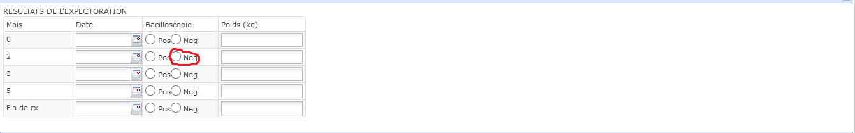

**Denominator**: All patients in treatment with a TPM + on month 0.

1. In treatment. Criteria 1 for numerator of A9.
2. TPM + for month 0. One of the following:
   1. marked“crachat” | tbDxCrachat = 1
   2. “Bacilloscopie” on Mois 0 is positive | tbEvalresult0 = 1
   3. 
3. Taux de conversion des crachats au 3ème mois

Percentage of TB patients in treatment who converted from a positive sputum (TPM +) on month 0 to negative on month 3.

|  |  |
| --- | --- |
| **Numérateur**: nombre de cas de TPM+ négativés au 3eme mois  **Dénominateur**: nombre de TPM+ placés sous traitement | **Numerator:** Patients in treatment who converted from a positive sputum (TPM+) on month 0 to negative on month 3.  **Denominator:** patients in treatment with a positive sputum (TPM +) on month 0 . |

Same specifications as A11, except the numerator should be month 3 instead of month 2. The Denominator is still only considering month 0.

1. Taux de guérison

Cure rate

|  |  |
| --- | --- |
| **Numérateur**: nombre de cas de TPM+ guéris  **Dénominateur**: nombre total de TPM+ placé sous traitement. | **Numerator:** Tb patients cured with positive sputum (TPM +) and on treatment   **Denominator:** TB patients with positive sputum (TPM+) and on treatment. |

WHO definition: patient who was initially smear-positive and who was smear-negative in the last month of treatment and on at least one previous occasion.

**Numerator**: Patients who were TPM + and on treatment who were cured.

1. Cured. One of the following:
   1. “Gueri” is marked | tbStopReason = 1
   2. 
2. TPM + on month 0. Criteria 2 for denominator of A11.
3. In treatment. Criteria 1 for numerator of A9.

**Denominator**: All patients who are TPM + and in treatment.

* + - 1. In treatment. Criteria 1 for numerator of A9.
      2. TPM + on month 0. Criteria 2 for denominator of A11.

1. Taux de traitement terminé (TPM+)

Rate of treatment completion

|  |  |
| --- | --- |
| **Numérateur**: nombre de cas de TPM+ ayant terminé le traitement.  **Dénominateur**: nombre total de TPM+ placé sous traitement. | **Numerator:** Patients who were TPM + and finished treatment. **Denominator:** All patients who are TPM + and on treatment. |

WHO definition: A patient who completed treatment but did not meet the criteria for cure or failure. This definition applies to pulmonary smear-positive and smear-negative patients and to patients with extrapulmonary disease.

**Numerator**: Patients who were TPM + and finished treatment.

1. Finished treatment. One of the following:
   1. “traitement terminè” is marked | tbStopReason = 2
   2. 
2. TPM + on month 0. Criteria 2 for denominator of A11.

**Denominator**: All patients who are TPM + and on treatment. Same is denominator for A1

1. Taux de traitement terminé (TPM-)

Rate of treatment completion

|  |  |
| --- | --- |
| **Numérateur**: nombre de cas de TPM- ayant terminé le traitement.  **Dénominateur**: nombre total de TPM- placé sous traitement. | **Numerator:** Patients who were TPM - and finished treatment. **Denominator:** All patients who are TPM - and on treatment |

**Numerator**: Patients who were TPM - and finished treatment.

1. Finished treatment. One of the following:
   1. “traitement terminè” is marked | tbStopReason = 2
   2. 
2. TPM -
   1. “Neg Bacilloscopie” on Mois 0 | tbEvalresult0 = 2

**Denominator**: All patients who are TPM - and on treatment

1. On treatment. Same as criteria 1 for numerator of A9
2. TPM - on month 0.
   * + - 1. “Neg Bacilloscopie” on Mois 0 | tbEvalresult0 = 2
3. Taux de succès (TPM+)

Success rate (TPM +)

|  |  |
| --- | --- |
| **Numérateur**: nombre de cas de TPM+ guéris ayant terminé le traitement.  **Dénominateur**: nombre total de TPM+ placé sous traitement. | **Numerator:** Patients who were initially TPM + and cured OR finished treatment.  **Denominator:** Patients who has a positive sputum (TPM+) and in treatment. |

WHO definition: A patient who was cured or who completed treatment.

**Numerator**: Patients who were initially TPM + and cured OR finished treatment. Meets the criteria for the numerator of A13 OR the numerator of A14.

**Denominator**: Patients who were initially TPM + and in treatment. Same as denominator for A13

1. Taux d´échec

Failure rate

|  |  |
| --- | --- |
| **Numérateur**: nombre de cas de TPM+ positifs au 5eme mois.  **Dénominateur**: nombre total de TPM+ placé sous traitement. | **Numerator:** All patients initially TPM+ who failed treatment. **Denominator:** All patients who are TPM + and on treatment. |

WHO definition: A patient who was initially smear-positive and who remained smear-positive at month 5 or later during treatment.

**Numerator**: All patients initially TPM+ who failed treatment.

1. One of the following:

* 1. “Echec” is marked | tbStopReason = 4
  2. Bacillscopie” on “Mois 5” is positive | tbEvalresult5 = 1
  3. “Bacillscopie” on “fin” is positive | tbEvalresultFin = 1
  4. 

1. TPM + and on treatment. Same as denominator for A13.

**Denominator**: All patients who are TPM + and on treatment. Same as denominator for A13.

1. Taux d´ábandon

Dropout rate

|  |  |
| --- | --- |
| **Numérateur**: nombre de cas de TPM+ ayant abandonné le traitement.  **Dénominateur**: nombre total de TPM+ placé sous traitement. | **Numerator:** All patients with initial TPM+ who did not finish treatment **Denominator:** All patients who are TPM + have been started on treatment in the past |

**WHO Definition**: A patient whose treatment was interrupted for 2 consecutive months or more.

**Numerator**: All patients with initial TPM+ who did not finish treatment

1. TPM + on month 0. Criteria 2 for denominator of A11.
2. Abandoned treatment. One of the following:
   1. “abandon” is marked | tbStopReason = 8
   2. 

**Denominator**: All patients who are TPM + have been started on treatment in the past. Same as denominator for A 13

1. Taux de décès

Death rate among those with TPM + on treatment.

|  |  |
| --- | --- |
| **Numérateur**: nombre de cas de TPM+ décédés au cours du traitement.  **Dénominateur**: nombre total de TPM+ placé sous traitement. | **Numerator:** All patients with initial TPM+ and on treatment who died **Denominator: Patients in treatment.** |

**Numerator**: All patients with initial TPM+ and on treatment who died

1. TPM + and on treatment. Same as denominator for A13.
2. Deceased:
   1. “Decèdè” is marked | tbStopReason = 32
   2. 

**Denominator**: All patients who are TPM + have been started on treatment. Same as denominator for A13.

1. Taux de transfert

Transfer rate

|  |  |
| --- | --- |
| **Numérateur**: nombre de cas de TPM+ transférés au cours du traitement.  **Dénominateur**: nombre total de TPM+ placé sous traitement. | **Numerator:** All patients with initial TPM+ who transferred treatment treatment. **Denominator:** All patients who are TPM + have been started on treatment in the past. |

**Numerator**: All patients with initial TPM+ who transferred treatment

1. Transferred treatment:
   1. “transfèrè” is marked | tbStopReason = 16
   2. 
2. TPM + and on treatment. Same as denominator for A13.

**Denominator**: All patients who are TPM + have been started on treatment in the past. Same as denominator for A13.

1. Pourcentage de patients tuberculeux testés pour le VIH

Percentage of TB patients tested for HIV

|  |  |
| --- | --- |
| **Numérateur**: nombre de patients tuberculeux testés pour le VIH.  **Dénominateur**: nombre total de patients tuberculeux diagnostiqués. | **Numerator:** TB patients tested for HIV.  **Denominator:** All TB patients. |

**Numerator**: All TB patients tested for HIV

1. All TB patients (denominator, A21).
2. Either of the following:
   1. HIV test positive |tbTestVIH = 4
   2. HIV test negative | tbTestVIH = 2

**Denominator**: All TB patients. Any of the following:

* + 1. New or old cases

1. “Nouveau diagnostic” is marked | tbDxNew = 1
2. 
   * 1. Pulmonary TB. One o the following marked:
3. “Diagnostic Bas sur X-Ray” | tbDxXray = 1
4. “Diagnostic Bas sur crachet” | tbDxCrachat = 1
5. “Classification de maladie Pulmonaire” | tbClassPulmonaire = 1
6. “Bacilloscopie” on Mois 0 is positive | tbEvalresult0 = 1
7. 
   * 1. Extrapulmonary TB. One of the following marked:
8. “Classification de maladie Extra-Pulmonaire” | tbClassExtra = 1
9. Meningite, pleural, miliare, ganglionnaire, intestinale, or “other” | tbMeningite, tbPleurale, tbMiliaire, tbGanglionnaire, tbIntestinale, or tbClassOther = 1
   * 1. 
10. Pourcentage de co-infectés parmi les patients tuberculeux testés

Percentage of TB patients who tested positive for HIV

|  |  |
| --- | --- |
| **Numérateur**: nombre de patients tuberculeux VIH+.  **Dénominateur**: nombre total de patients tuberculeux diagnostiqués. | **Numerator:** TB patients that are HIV Positive.  **Denominator:** TB Patients tested for HIV. |

**Numerator**: Patients with TB and HIV +

1. All TB patients (See criteria 1 for denominator in A22)

1. HIV +
   1. HIV test positive |tbTestVIH = 4

**Denominator**: All TB patients tested for HIV.

1. All TB patients
2. New or old cases
3. “Nouveau diagnostic” is marked | tbDxNew = 1
4. “Suivi” marked | tbDxNew = 2
5. 
6. Pulmonary TB. One o the following marked:
7. “Diagnostic Bas sur X-Ray” | tbDxXray = 1
8. “Diagnostic Bas sur crachet” | tbDxCrachat = 1
9. “Classification de maladie Pulmonaire” | tbClassPulmonaire = 1
10. “Bacilloscopie” on Mois 0 is positive | tbEvalresult0 = 1
11. 
12. Extrapulmonary TB. One of the following marked:
13. “Classification de maladie Extra-Pulmonaire” | tbClassExtra = 1
14. Meningite, pleural, miliare, ganglionnaire, intestinale, or “other” | tbMeningite, tbPleurale, tbMiliaire, tbGanglionnaire, tbIntestinale, or tbClassOther = 1
15. 
16. Tested for HIV
    1. HIV test positive or negative |tbTestVIH > 1
17. Pourcentage de co-infectés sous traitement prohylactique au cotrimoxazole

Percentage of TB patients co-infected with HIV being treated with cotrimoxazole prophylaxis

|  |  |
| --- | --- |
| **Numérateur**: nombre de patients co-infectés recevant le cotrimoxazole  **Dénominateur**: nombre total de patients co-infectés diagnostiqués. | **Numerator:** TB patients co-infected with HIV receiving cotrimoxazole prophylaxis.  **Denominator:** All TB patients co-infected with HIV. |

**Numerator**: TB patients co-infected with HIV receiving cotrimoxazole.

1. All TB patients co-infected with HIV. See numerator of A22
2. Cotrimazole prophylaxis
   1. Cotrimazole marked under “prophylaxie” | propCotrimoxazole = 1



**Denominator**: Patients with TB + and HIV +. Same as numerator for A22.

1. Pourcentage de co-infectés mis sous ARV

Percentage of TB patients co-infected with HIV on ARVs

|  |  |
| --- | --- |
| **Numérateur**: nombre de patients co-infectés recevant des ARV  **Dénominateur**: nombre total de patients co-infectés diagnostiqués. | **Numerator** TB patients co-infected with HIV on ARVs  **Denominator:** TB patients co-infected with HIV |

**Numerator**: Patients with TB + and HIV + on ARVs

1. TB + and HIV +. See numerator for A22:
2. On ARVs
   1. “Oui” is marked for “ARV” | tbArvYN = 1
   2. 

**Denominator**: Same as numerator for A22. Patients with TB + and HIV +

1. TB + and HIV +. see numerator for A22.
2. Taux d´incidence de tuberculose enregistré.

Percentage of new TB cases among visits in iSante in a given time period

|  |  |
| --- | --- |
| **Numérateur:** Nouveaux cas de tuberculose diagnostiqués dans une période de temps donnée  **Dénominateur:** nombre de visites iSante dans une période de temps donnée (y compris les patients VIH) | **Numerator:** New TB cases among visits in iSante in a given time period  **Denominator:** visits in iSante in a given time period (include HIV patients) |

**Numerator**: New TB cases among the visits in iSante patients in a given time period

* 1. New TB cases
     1. Meets criteria for denominator of A7 or denominator of A8 (i.e. all new tb patients rather than just adults or just children)
  2. Must be within the specified time period

**Denominator**: All visits in iSante in given time period.

1. Taux d´incidence des TPM+ enregistré

Percentage of new positive sputum (TPM+) among visits in iSante in a given time period.

|  |  |
| --- | --- |
| **Numérateur:** nombre total de nouveaux cas de TPM+ diagnostiqués pendant une période donnée  **Dénominateur:** nombre de visites iSante dans une période de temps donnée (y compris les patients VIH) | **Numerator:** New positive sputum (TPM+) among visits in iSante in a given time period  **Denominator:** visits in iSante in a given time period (include HIV patients) |

**Numerator**: New TPM + among the visits in iSante patients in a given time period

1. Meets criteria for numerator of A3 or numerator of A4 (i.e. all new TPM + rather than just adults or just children)

**Denominator**: All visits in iSante in given time period. Same as denominator for A26.

1. Taux de méningite tuberculeuse enregistré chez les moins de 60 moi s

Percentage of TB meningitis in the population < 60 months old

|  |  |
| --- | --- |
| **Numérateur:** nombre total de cas de méningite TB diagnostiqués pendant une période donnée  **Dénominateur:** nombre total d’enfants < 5ans | **Numerator:** Children < 60 months with TB meningitis in a given time period  **Denominator:** Total children <60 months in iSante with a visit in a given time period. |

**Numerator**: All patients in iSante <60 months with TB meningitis

1. < 60 months old
2. “Meningite” marked under “classification de la maladie” | tbMeningite = 1



**Denominator**: All patients in iSante < 60 months old

1. < 60 months
2. Taux de létalité par tuberculose

Percentage of deaths among those with TB

|  |  |
| --- | --- |
| **Numérateur :**# de patients décédés en cours du traitement.  **Dénominateur :**Patients en traitement. | **Numerator:** Deaths among those with TB  **Denominator:** All TB patients |

**Numerator**: All patients with TB who died

1. All TB (See criteria 1 for denominator in A22)
2. In treatment (criteria 1 for numerator of A9).
3. Deceased:
   1. “Decèdè” is marked | tbStopReason = 32



**Denominator**: All patients with TB in treatment.

1. All TB (See criteria 1 for denominator in A22)
2. In treatment (criteria 1 for numerator of A9).

# B. Status indicator

1. Nouveau Diagnostiques

|  |  |
| --- | --- |
| Patients ayant recu leur diagnostique au cours de la periode. | Newly diagnosed TB patients in a given period |

* + - * 1. “Nouveau diagnostic” is marked | tbDxNew = 1

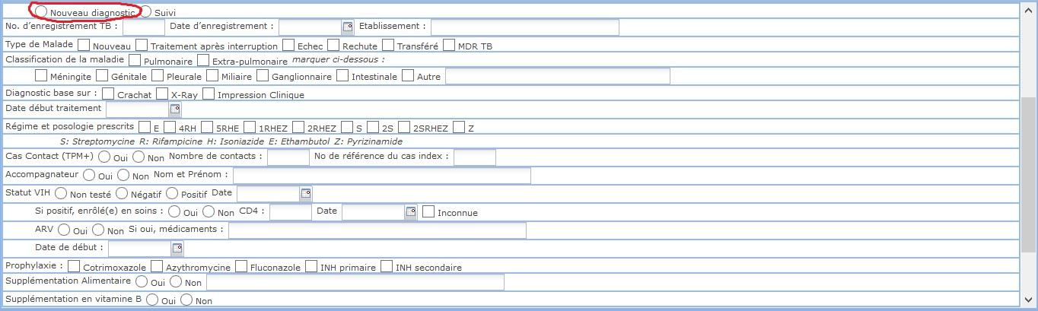

1. Nouveaux traitement

|  |  |
| --- | --- |
| Patients ayant initie leur traitement au cours de la periode. | Number of patients who started their TB treatment within the given time period. |

See criteria 1 of numerator in A9.

1. Traitement complete :

|  |  |
| --- | --- |
| un patient qui a terminé le traitement, mais ne répondent pas aux critères de guérison ou échec | a patient who completed treatment but did not meet the criteria for cure or failure |

.

1. Finished treatment. Same as numerator A14, criteria 1.
   1. “traitement terminè” is marked | tbStopReason = 2
   2. 
2. Gueri

|  |  |
| --- | --- |
| Tous les patients tuberculeux guéris. | All TB patients cured. |

1. Cured. Same as criteria 1 for the numerator of A13.

# C. Rapports qualite de soins

1. Rappels de rendez-vous mensuel

Report of upcoming visits (First name, last name, National code)

1. All TB patients (See criteria 1 of denominator in A22)

2. And the “Date de prochaine visite” next visit date should be between the next 4 week or if possible in a time period defined by the end user.

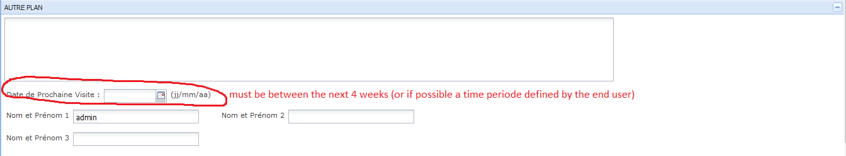

1. Rappel d’analyses de laboratoire (Never had eval0 sputum test)

Test jamais effectue :

|  |  |
| --- | --- |
| Liste des patients atteints de tuberculose qui n'a jamais eu un essai de suivi de l'expectoration (TPM). | List of TB patients who never had a follow up sputum (TPM) test. |

* + - 1. All TB patients (See criteria 1 for denominator in A22)
      2. No sputum done. All of the following must be true to meet this criteria:
         1. TPM is not resulted | crachat = 0
         2. “crachat” is not marked| tbDxCrachat = 0
         3. “Bacilloscopie” on Mois 0 | tbEvalresult0 = 0

1. Rappel d’analyses de laboratoire (Had eval0 but not eval2)

|  |  |
| --- | --- |
| **Numérateur:** Patients évalués pour crachat en mois 0, mais pas dans le mois 2  **Dénominateur:** Les patients évalués pour des crachats au cours du mois 0 | **Numerator**: Patients evaluated for sputum in month 0 but not in month 2  **Denominator**: Patients evaluated for sputum in month 0 |

**Numerator**: Patients evaluated for sputum in month 0 but not in month 2

1. Had sputum at Month 0:
2. “Pos Bacilloscopie” on Mois 0 | tbEvalresult0 = 1
3. “Neg Bacilloscopie” on Mois 0 | tbEvalresult0 = 2
4. Did not have sputum at Month 2:
   1. “Bacilloscopie” on Mois 0 not marked| tbEvalresult0 = 0

**Denominator**: Patients evaluated for sputum in month 0

* + 1. Had sputum at Month 0:
       - 1. “Pos Bacilloscopie” on Mois 0 | tbEvalresult0 = 1
         2. “Neg Bacilloscopie” on Mois 0 | tbEvalresult0 = 2

1. Rappel d’analyses de laboratoire (Had eval2 but not eval3)

|  |  |
| --- | --- |
| **Numérateur:** Patients évalués pour crachat en mois 2, mais pas dans le mois 3  **Dénominateur:** Les patients évalués pour des crachats au cours du mois 2 | **Numerator**: Patients evaluated for sputum in month 2 but not in month 3  **Denominator**: Patients evaluated for sputum in month 2 |

**Numerator**: Patients evaluated for sputum in month 2 but not in month 3

1. Had sputum at Month 2:
   1. “Pos Bacilloscopie” on Mois 2 | tbEvalresult2 = 1
   2. “Neg Bacilloscopie” on Mois 2 | tbEvalresult2 = 2
2. Did not have sputum at Month 3:
   1. “Bacilloscopie” on Mois 3 not marked| tbEvalresult3 = 0

**Denominator**: Patients evaluated for sputum in month 2

* + 1. Had sputum at Month 2:
       - 1. “Pos Bacilloscopie” on Mois 2 | tbEvalresult2 = 1
         2. “Neg Bacilloscopie” on Mois 2 | tbEvalresult2 = 2

1. Rappel d’analyses de laboratoire (Had eval3 but not eval5)

|  |  |
| --- | --- |
| **Numérateur:** Patients évalués pour crachat en mois 3, mais pas dans le mois 5  **Dénominateur:** Les patients évalués pour des crachats au cours du mois 3 | **Numerator**: Patients evaluated for sputum in month 3 but not in month 5  **Denominator**: Patients evaluated for sputum in month 3 |

**Numerator**: Patients evaluated for sputum in month 3 but not in month 5

1. Had sputum at Month 3:
   1. “Pos Bacilloscopie” on Mois 3 | tbEvalresult3 = 1
   2. “Neg Bacilloscopie” on Mois 3 | tbEvalresult3 = 2
2. Did not have sputum at Month 5:
   1. “Bacilloscopie” on Mois 5 not marked| tbEvalresult5 = 0

**Denominator**: Patients evaluated for sputum in month 3

1. Had sputum at Month 3:
2. “Pos Bacilloscopie” on Mois 3 | tbEvalresult3 = 1
3. “Neg Bacilloscopie” on Mois 3 | tbEvalresult3 = 2
4. Rappel d’analyses de laboratoire (Had eval5 but not evalFin)

|  |  |
| --- | --- |
| **Numérateur:** Patients évalués pour crachat en 3 mois, mais pas à la fin du traitement  **Dénominateur**: Les patients évalués pour des crachats au cours du mois 5 | **Numerator**: Patients evaluated for sputum in month 3 but not at the end of treatment  **Denominator**: Patients evaluated for sputum in month 5 |

**Numerator**: Patients evaluated for sputum in month 5 but not at the end of treatment

1. Had sputum at Month 5:
   1. “Pos Bacilloscopie” on Mois 5 | tbEvalresult5 = 1
   2. “Neg Bacilloscopie” on Mois 5 | tbEvalresult5 = 2
2. Did not have sputum at the end of treatment:
   1. “Bacilloscopie” on Fin de Rx not marked| tbEvalresultFin = 0

**Denominator**: Patients evaluated for sputum in month 5

1. Had sputum at Month 5:
2. “Pos Bacilloscopie” on Mois 5 | tbEvalresult5 = 1
3. “Neg Bacilloscopie” on Mois 5 | tbEvalresult5 = 2
4. Rappel d’analyses de laboratoire (no xray)

List of TB patients who have not had an xray done.

1. TB patients (See criteria 1 for denominator in A22)
2. Chest x-ray performed (normal or abnormal) | xray > 0
3. Liste de (SR) > 2 semaines ayant initie examens de crachat diagnostiques.

List of patients who have had respiratory symptoms (cough > 2 weeks or dypnea) and received a sputum test ordered (TPM).

-See numerator of A1

1. Liste de (SR) > 2 semaine n’ayant pas complete 3 examens de crachats diagnostques

**How to compute:**

This is the list of all patients with respiratory problems who did not complete a series of 3 sputum. We already know how to select patients with respiratory problems from indicator 3.

A patient who did not complete a series of 3 sputum has either one of these two specimen 3 not checked:

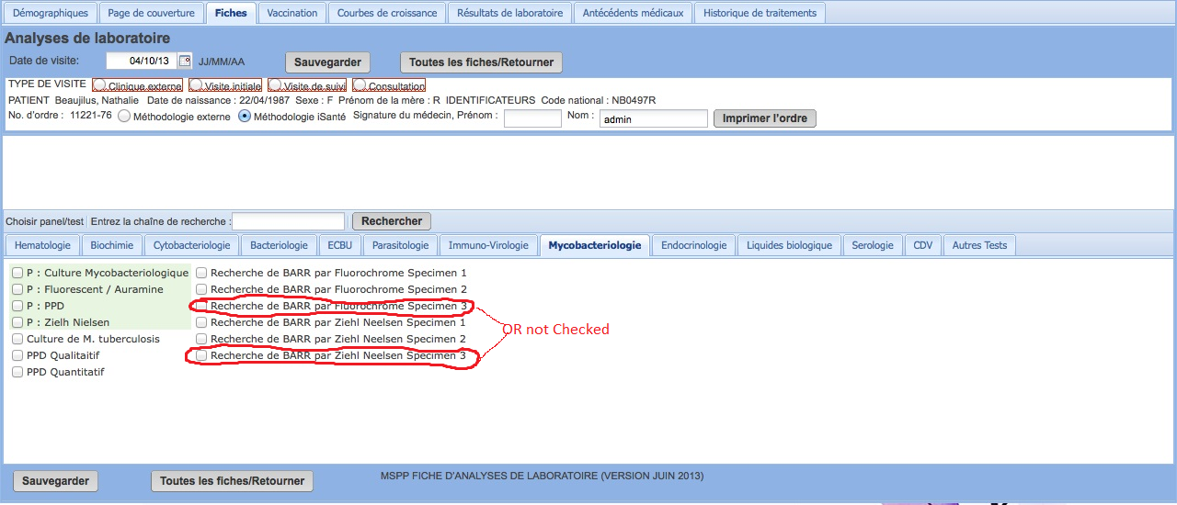

1. Percentage de (SR) > 2 semaine n’ayant pas beneficie d’examens de crachat diagnostique.

Percentage of all patients with respiratory problems who never had a sputum resulted.

|  |  |
| --- | --- |
| **Numérateur**: tous les patients présentant une toux> 2 semaines ou dyspnea qui n'ont jamais eu un crachat entraîné (TPM + ou -)  **Dénominateur**: tous les patients présentant une toux> 2 semaines ou dyspnea | **Numerator**: all patients with cough > 2 weeks or dyspnea who have never had a sputum resulted (TPM + or -)  **Denominator**: all patients with cough > 2 weeks or dyspnea |

**Numerator**: all patients with respiratory problems who never had a sputum resulted

* + 1. Respiratory problems (see criteria 1 of numerator of A1)
    2. TPM resulted. None of the following:
       - 1. TPM + or - resulted | crachat > 0
         2. marked“crachat” | tbDxCrachat = 1
         3. “Pos or neg Bacilloscopie” on Mois 0 | tbEvalresult0 > 0

**Denominator**: all patients with respiratory problems (see criteria 1 of numerator of A1)

1. Liste de Patients TPM+

List of patients TPM+

How to compute:

-See criteria 2 of numerator for A2

1. Percentage de patients diagnostique TB pulmonaire sans examen de crachat diagnostique.

Percentage of patients for whom the diagnosis of pulmonary TB was done without a sputum.

**Numerator**: Pulmonary TB and no sputum

1. Pulmonary TB. See criteria 3 of the denominator for A3.
2. No sputum done. Criteria 2, C2

**Denominator**: All Pulmonary TB patients

**1**. Pulmonary TB. See criteria 3 of the denominator for A3

# D. HeathQual Indicators

CDC has requested that all numerators and denominators be clickable for each individual HealthQual indicators. The click should point to a population list.

For example: The percentage of patients over 50 who had a colon cancer screening this month.

**63% 126/200 37%**

The hyperlink on 126 should produce the list of patients who had the screening done in the time period. The hyperlink on 200 should produce the list of patients over 50 for the time period. And the link on the 37% should produce the list of patients who didn’t have the screening done.

1. Pourcentage de patients Diagnostique TB ayant inite leur traitement leur dans un mois suivant le diagnostique.

Percentage of TB patients who started treatment within 30 days of being diagnosed.

**Numerator**: TB patients who started Treatment within 30 days of being diagnosed.

1. TB patients (See criteria 1 for denominator in A22)
2. Started treatment within 30 days of being diagnosed
3. diagnosis date: The date that any of the criteria for “TB patients” is first documented
4. start treatment date

The date marked under “date debut traitemant”

* + - 1. 

**Denominator**: All TB patients (See criteria 1 for denominator in A22)

1. Pourcentage de patients TB TPM+ places sous traitement ayant eu leur crachat de controle.

Percentage of TPM+ TB patients on treatment with follow up sputum performed.

|  |  |
| --- | --- |
| **Numérateur**: les patients tuberculeux avec une expectoration positive (TPM +) sur le traitement avec un suivi crachats effectuée.  **Dénominateur**: patients tuberculeux avec une expectoration positive (TPM +) qui reçoivent un traitement. | **Numerator**: TB patients with a positive sputum (TPM+ ) on treatment with follow up sputum performed.  **Denominator**: TB patients with a positive sputum (TPM +) who are receiving treatment. |

**Numerator**: TB patients with a positive sputum (TPM+ ) on treatment with follow up sputum performed.

1. TPM+. One of the following:
   1. marked“crachat” | tbDxCrachat = 1
   2. “Pos Bacilloscopie” on Mois 0 | tbEvalresult0 = 1
2. On treatment (See criteria 1 for numerator of A9)
3. Follow up sputum performed. Any of the following:
   1. Positive or neg baciliscopie Month 2| tbEvalresult2 > 0
   2. Positive or neg baciliscopie Month 3 | tbEvalresult3 > 0
   3. Positive or neg baciliscopie Month 5 | tbEvalresult5 > 0
   4. Positive or neg baciliscopie at the end of treatment | tbEvalresultFin >0
   5. 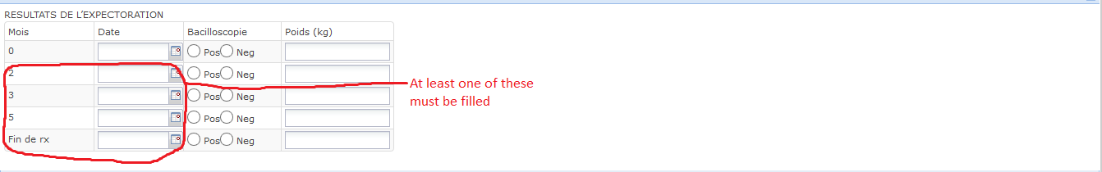

**Denominator**: TB patients with a positive sputum (TPM +) who are receiving treatment.

1. TPM+. One of the following:
   1. marked“crachat” | tbDxCrachat = 1
   2. “Pos Bacilloscopie” on Mois 0 | tbEvalresult0 = 1
2. On treatment (See criteria 1 for numerator of A9)
3. Pourcentage de symptomatique respiratoire(SR)> 2 semaine ayant beneficie d’un examen de crachat diagnostique.

|  |  |
| --- | --- |
| **Numérateur**: tous les patients présentant une toux> 2 semaines ou dypnea qui avaient un crachat entraîné (TPM + ou -)  **Dénominateur**: tous les patients présentant une toux> 2 semaines ou dypnea | **Numerator**: all patients with cough > 2 weeks or dypnea who had a sputum resulted (TPM + or -)  **Denominator**: all patients with cough > 2 weeks or dypnea |

**Numerator**: all patients with respiratory problems who had a sputum resulted (TPM + or -)

1. Respiratory problems (see criteria 1 of numerator of A1)
2. TPM resulted. One of the following:
3. TPM + or - resulted | crachat > 0
4. marked“crachat” | tbDxCrachat = 1
5. “Pos or neg Bacilloscopie” on Mois 0 | tbEvalresult0 > 0

**Denominator**: all patients with respiratory problems (see criteria 1 of numerator of A1)

# E. Statistiques de services

1. Nombre de symptomatiques respiratoires identifies

Number of patients with respiratory problems (in specified time period)

-See criteria 1 of the numerator for A1

1. Nombre de symptomatiques respiratoires (SR) ayant beneficie d’examens de crachat diagnostique.

Number of patients with respiratory problems who had a sputum done

-See numerator of D3

1. Nombre de symptomatiques respiratoires (SR) avec resultats de crachats diagnostique positif.

Number of patients with respiratory problems who had a positive sputum (TPM+)

-Numerator of A2

1. Nombre de SR avec resultat de crachat diagnostique negative.

Number of patients with respiratory problems who had a negative sputum (TPM -)

1. Respiratory symptoms. Any of the following:
   1. Cough > 2 weeks | touxGreat2 = 1
   2. Dyspnea | dyspnea = 1
   3. 
2. Sputum negative (TPM -). Any of the following:
   1. TPM - resulted | crachat = 2
   2. TPM - on TB forms
      * 1. “Neg Bacilloscopie” on Mois 0 | tbEvalresult0 = 2
3. Taux de detection = Nombre TB+ / Nombre teste pour TB.

Rate of detection

|  |  |
| --- | --- |
| Numérateur: nombre de TPM +  Dénominateur: Nombre de TPM + ou TPM- | **Numerator**: number of TPM +  **Denominator**: Number of TPM + or TPM – |

**Numerator**: number of TPM +

-Criteria 2 of numerator for A2

**Denominator**: Number of TPM + or TPM –

-Criteria 2 for the denominator of A2

1. Nombre de patient diagnostique TB--pulmonaire.

Number of pulmonary TB patients diagnosed

-See criteria 3 for denominator of A3

1. Nombre de patient diagnostique TB—non-pulmonaire.

Number of patients diabnostic with extrapulmonary TB

-Critera 3 for numerator of A7

1. Nombre de Diagnostique etabli par Clinique,Crachats, X-Ray.

Number of TB cases diagnosed by clinical impression, sputum or Xray

Any of the following:

1. “Diagnostic Bas sur X-Ray” | tbDxXray = 1
2. “Diagnostic Bas sur crachet” is marked | tbDxCrachat = 1
3. “Diagnostic Bas sur impression clinique” is marked | tbDxClinique = 1
4. Nombre de Patients Diagnostique TB pulmonaire avec Crachats positif.

Number of patients diagnosed with pulmonary TB via positive sputum (TPM+)

TPM+ = One of the following:

1. marked“crachat” | tbDxCrachat = 1
2. “Pos Bacilloscopie” on Mois 0 | tbEvalresult0 = 1
3. Nombre de Patients Diagnostique TB pulmonaire avec Crachats Negatif.

Number of patients diagnosed with pulmonary TB who have a negative sputum (TPM -)

-See criteria 3 and 4 of numerator of A5.

1. Nombre de patients Diagnostique TB pulmonaire sans Crachat.

Numer of pulmonary TB patients diagnosed without sputum being performed (TPM)

-Pulmonary TB: See criteria 3 for denominator of A3

-Without sputum:

Both of the following are true:

1. “crachat” not marked| tbDxCrachat = 0
2. “Bacilloscopie” on Mois 0 is not marked | tbEvalresult0 = 0
3. Nombre de patient TB place sous Traitement--Nouveau.

Number of new TB patients on treatment

-New TB: “ Nouveau diagnostic” | tbDxNew = 1

-On treatment: criteria 1 for numerator of A9

1. Nombre de patient TB place sous Traitement--Rechute.

Number of TB patients on treatment who relapsed.

1. relapsed:



2. On treatment: criteria 1 for numerator of A9

1. Liste de patients Dx TB non encore places sous RX

List of TB patients no receiving treatment

* + 1. TB patients (See criteria 1 of denominator in A22)
    2. Not receiving treatment. None of the following

1. “Date Debut traitement” filled in | tbStartTreatment = 1
2. Any of the medication boxes competed in “Regime et posologie precrite” | tbRegimine = 1
3. Liste des patients ayant complété leur 6 mois de traitement avec un crachat de vérification positif TPM+ (Echec)

List of patients who failed treatment. (See numerator for A17)

1. Liste de patients TB Pulmonaire ayant complete leur 6 mois d'enrollement et n'ayant pas beneficie d'un examen de crachat de verification

List of pulmonary TB patients enrolled for at least 6 months who haven’t had a sputum verification